Supplementary Information
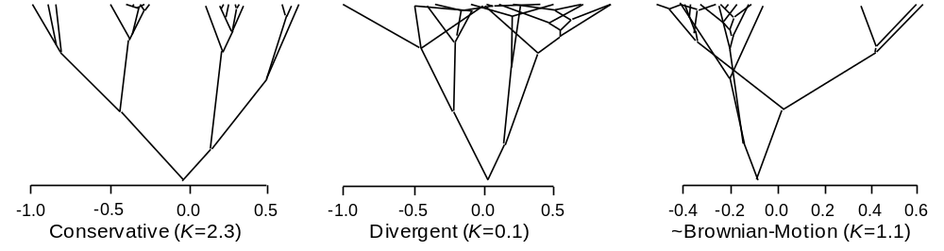
Supplementary Figure 1 Graphical representation (i.e. traitgrams following Ackerly⁸) of conserved (left), divergent (center), and Brownian-Motion (right) trait evolution. The x-axis represents trait values at the tips, and ancestral state estimates for internal nodes based on phylogenetic independent contrasts. All three examples were significantly different from a random assignment of trait values to the tips of the phylogeny. Phylogenetic conservatism may arise from stabilizing selection, gene flow that reduces local adaptation, genetic constraints (e.g. pleiotropy) and lack of genetic variation². Note that divergence among sister taxa can lead to convergence with more distantly related taxa. Trait divergence may be due to niche partitioning among closely related species, or multiple independent adaptations to novel environments. Brownian-Motion (BM) is a more “neutral” model of trait evolution, in which trait values change in proportion to evolutionary distance between clades.

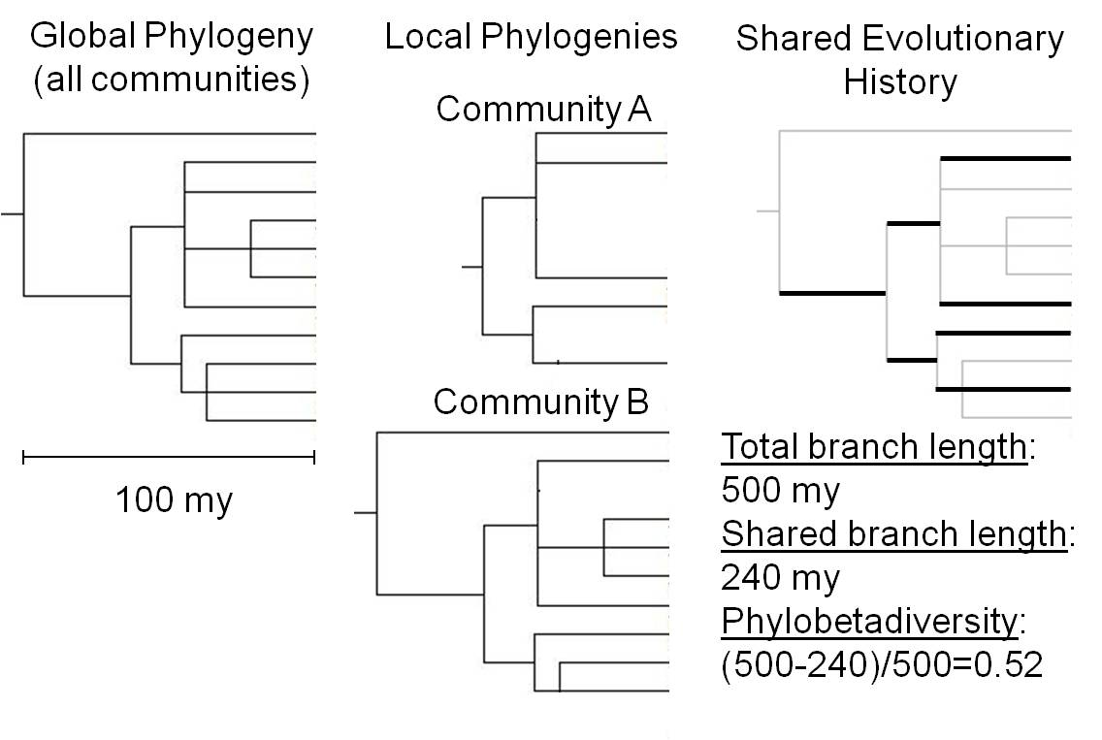
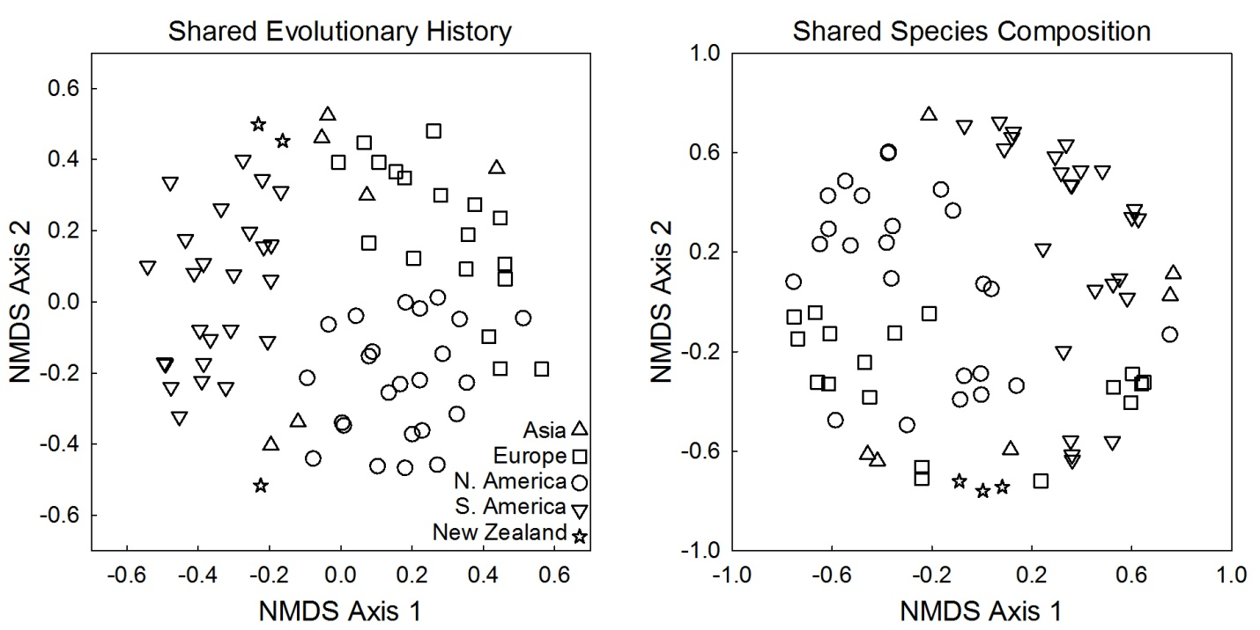
Supplementary Figure 2 Graphical representation of phylobetadiversity and biogeographic patterns of evolutionary turnover across the 77 sampled alpine plant communities. The two local communities (upper panel) have a turnover of evolutionary history of 52%, whereas species turnover is 64% (3/11 shared species). Dark branches (right panel) represent shared evolutionary history. The biogeographic patterns in the lower panel are based on an ordination (non-metric multidimensional scaling) of phylogenetic distances across communities based on phylobetadiversity estimates (left panel). A traditional ordination (right panel) based on species’ presence-absence data is relatively uninformative by comparison, given the low incidence of species occurring in multiple sites.

Cushion species | Country | Latitude | Longitude | Altitude (m)
Xenophyllum rigidum | Ecuador | -0.47171 | -78.1582 | 4700
Azorella aretioides | Ecuador | -0.46746 | -78.1668 | 4550
Azorella aretioides | Ecuador | -0.47227 | -78.1586 | 4700
Picnophyllum bryoides | Chile | -22.5756 | -68.037 | 4300
Adesmia subterranea | Chile | -30.4175 | -70.2631 | 3744
Adesmia subterranea | Chile | -30.3942 | -70.2419 | 3922
Azorella madreporica | Chile | -33.3192 | -70.2597 | 3600
Azorella madreporica | Chile | -33.3161 | -70.2358 | 3625
Laretia acaulis | Chile | -33.3261 | -70.2833 | 3000
Laretia acaulis | Chile | -33.3292 | -70.2667 | 3300
Oreopolus glacialis | Chile | -37.4592 | -71.1228 | 2052
Azorella trifurcata | Chile | -37.4633 | -71.3167 | 1400
Mulinum leptacanthum | Argentina | -41.2675 | -71.3031 | 1700
Oreopolus glacialis | Argentina | -41.2675 | -71.3031 | 1700
Discaria nana | Argentina | -41.2675 | -71.3031 | 1700
Azorella monantha | Chile | -50.8244 | -73 | 710
Bolax gummiferia | Chile | -50.8239 | -72.9979 | 750
Azorella monantha | Chile | -50.8153 | -72.9922 | 890
Bolax gummiferia | Chile | -50.8173 | -72.9886 | 920
Silene acaulis | USA | 44.96947 | -109.44 | 3263
Trifolium nanum | USA | 44.9722 | -109.448 | 3231
Antennaria umbrinella | USA | 47.07824 | -112.372 | 1796
Eriogonum ovalifolium | USA | 46.88348 | -113.983 | 1117
Eriogonum ovalifolium | USA | 46.86773 | -113.964 | 1232
Eriogonum umbellatum | USA | 40.69498 | -110.905 | 3550
Geum rossii | USA | 35.34119 | -111.684 | 3650
Geum rossii | USA | 35.3425 | -111.682 | 3800
Raoulia sp | New Zealand | -43.5093 | 171.5442 | 1518
Dracophyllum sp | New Zealand | -45.3223 | 169.2077 | 1678
Phyllacne colensoi | New Zealand | -45.7524 | 167.3995 | 1456
Onobrychis cornuta | Lebanon | 33.97534 | 35.84794 | 2222
Astragalus zachlensis | Lebanon | 33.97746 | 35.84816 | 2223
Astragalus macrosemius | Iran | 35.89417 | 51.40694 | 3676
Silene acaulis | Slovakia | 49.23583 | 20.21917 | 1982
Silene acaulis | Norway, Svalbard | 78.91226 | 12.01743 | 30
Silene acaulis | Switzerland | 46.47778 | 9.582778 | 2484
Silene acaulis | Switzerland | 46.42502 | 7.6292 | 2297
Minuartia recurva | Spain | 40.80001 | -3.93339 | 2340
Azorella madreporica | Chile | -33.3339 | -70.2467 | 3258
Azorella madreporica | Chile | -33.3253 | -70.2386 | 3394
Azorella madreporica | Chile | -30.4175 | -70.2631 | 3744
Azorella madreporica | Chile | -30.3942 | -70.2419 | 3922
Laretia acaulis | Chile | -33.3339 | -70.2467 | 3259
Phlox condensata | USA | 37.53341 | -118.205 | 3603
Townsendia leptotes | USA | 37.54965 | -118.215 | 3563
Azorella monantha | Chile | -51.1758 | -72.8483 | 720
Sibbaldia sp | USA | 48.48485 | -113.322 | 2290
Silene acaulis | Canada | 49.05713 | -120.22 | 2476
Silene acaulis | Canada | 49.05052 | -120.218 | 2510
Silene acaulis | Canada | 51.20939 | -122.562 | 2191
Silene acaulis | Canada | 57.06065 | -122.864 | 1754
Saponaria caespitosa | Spain | 42.69026 | 0.648889 | 2318
Silene acaulis | Spain | 42.68947 | 0.646014 | 2318
Silene acaulis | Canada | 50.03248 | -122.571 | 2100
Silene acaulis | Canada | 50.03243 | -122.571 | 2100
Arenaria tetraquetra-amabilis | Spain | 37.03642 | -3.30325 | 2575
Arenaria tetraquetra-amabilis | Spain | 36.99721 | -3.31251 | 3110
Arenaria tetraquetra-amabilis | Spain | 37.08134 | -3.38127 | 2750
Arenaria tetraquetra-amabilis | Spain | 37.05082 | -3.37096 | 3239
Plantago holosteum | Spain | 37.08134 | -3.38127 | 2750
Arenaria kansuensis | China | 39.30208 | 96.30286 | 4239
Rhodiola juparensis | China | 39.3546 | 96.26245 | 3709
Astragalus strictus | Nepal | 28.13581 | 85.34395 | 4265
Silene acaulis | USA | 48.78032 | -113.767 | 2273
Silene acaulis | USA | 48.78443 | -113.767 | 2515
Dasiphora fruticosa | USA | 48.47894 | -113.332 | 2241
Silene acaulis | Sweden | 68.35748 | 18.49861 | 1050
Silene acaulis | Italy | 46.50636 | 12.02 | 2357
Minuartia sp | Italy | 46.53018 | 12.00271 | 2734
Cerastium alpinum | Italy | 46.50216 | 11.80855 | 2913
Silene acaulis | Italy | 46.52964 | 12.01633 | 2473
Silene acaulis | USA | 48.72482 | -113.682 | 2143
Silene acaulis | Canada | 50.61065 | -114.976 | 2516
Silene acaulis | USA | 48.47922 | -113.329 | 2280
Saxifraga oppositifolia | Canada | 49.05052 | -120.218 | 2510
Minuartia sedoides | Slovakia | 49.23583 | 20.21917 | 1982
Eriogonum gracilipes | USA | 37.55092 | -118.224 | 3726

Supplementary Table 1 Study locations and cushion species sampled.

 | Asia |  | Europe |  | N. America |  | S. America |  | New Zealand
Family | Exp | Obs | Exp | Obs | Exp | Obs | Exp | Obs | Exp | Obs
Apiaceae | 3 | 0 | 1 | 0 | 0 | 0 | 8 | 37 | 7 | 0
Asteraceae | 22 | 1 | 12 | 1 | 6 | 2 | 43 | 15 | 16 | 31
Berberidaceae | 0 | 0 | 0 | 0 | 0 | 0 | 2 | 0 | 0 | 0
Boraginaceae | 1 | 2 | 1 | 0 | 1 | 1 | 0 | 0 | 1 | 1
Brassicaceae | 5 | 15 | 9 | 9 | 3 | 0 | 11 | 9 | 1 | 0
Calceolareaceae | 0 | 0 | 0 | 0 | 0 | 0 | 1 | 0 | 0 | 0
Calyceraceae | 0 | 0 | 0 | 0 | 0 | 0 | 3 | 2 | 0 | 0
Campanulaceae | 1 | 0 | 3 | 0 | 0 | 0 | 0 | 2 | 1 | 0
Caryophyllaceae | 3 | 12 | 7 | 18 | 2 | 5 | 2 | 23 | 2 | 6
Cistaceae | 0 | 0 | 1 | 0 | 0 | 0 | 0 | 0 | 0 | 0
Convolvulaceae | 0 | 0 | 0 | 0 | 0 | 0 | 0 | 0 | 0 | 0
Crassulaceae | 2 | 1 | 2 | 2 | 1 | 0 | 0 | 0 | 0 | 0
Cucurbitaceae | 0 | 0 | 0 | 0 | 0 | 0 | 0 | 0 | 1 | 0
Dipsacaceae | 1 | 0 | 0 | 1 | 0 | 0 | 0 | 0 | 0 | 0
Ericaceae | 0 | 0 | 1 | 0 | 0 | 0 | 4 | 1 | 4 | 2
Euphorbiaceae | 1 | 0 | 0 | 0 | 0 | 0 | 0 | 0 | 0 | 0
Fabaceae | 4 | 5 | 5 | 1 | 1 | 2 | 11 | 4 | 0 | 0
Gentianaceae | 4 | 0 | 3 | 0 | 0 | 0 | 1 | 0 | 1 | 0
Geraniaceae | 1 | 0 | 0 | 0 | 0 | 0 | 2 | 0 | 1 | 0
Globulariaceae | 0 | 0 | 0 | 0 | 0 | 0 | 0 | 0 | 0 | 0
Hydrophyllaceae | 0 | 0 | 0 | 0 | 0 | 0 | 2 | 0 | 0 | 0
Lamiaceae | 3 | 0 | 3 | 0 | 0 | 0 | 1 | 0 | 0 | 0
Lentibulariaceae | 0 | 0 | 0 | 0 | 0 | 0 | 0 | 0 | 0 | 0
Linaceae | 0 | 1 | 0 | 0 | 0 | 0 | 0 | 1 | 0 | 0
Loasaceae | 0 | 0 | 0 | 0 | 0 | 0 | 1 | 0 | 0 | 0
Malvaceae | 0 | 0 | 0 | 0 | 0 | 0 | 1 | 6 | 0 | 0
Onagraceae | 1 | 0 | 0 | 0 | 0 | 0 | 2 | 0 | 1 | 0
Orobanchaceae | 3 | 0 | 3 | 0 | 0 | 0 | 0 | 0 | 1 | 0
Oxalidaceae | 0 | 0 | 0 | 0 | 0 | 0 | 4 | 5 | 0 | 0
Papaveraceae | 0 | 0 | 0 | 0 | 0 | 0 | 0 | 0 | 0 | 0
Parmeliaceae | 0 | 0 | 0 | 0 | 0 | 0 | 0 | 0 | 0 | 0
Peltigeraceae | 0 | 0 | 0 | 0 | 0 | 0 | 0 | 0 | 0 | 0
Plantaginaceae | 0 | 0 | 0 | 1 | 0 | 0 | 2 | 3 | 1 | 0
Plumbaginaceae | 1 | 2 | 0 | 3 | 0 | 0 | 1 | 0 | 0 | 0
Polemoniaceae | 0 | 0 | 0 | 0 | 1 | 3 | 0 | 0 | 0 | 0
Polygalaceae | 0 | 0 | 0 | 0 | 0 | 0 | 1 | 0 | 0 | 0
Polygonaceae | 1 | 0 | 3 | 0 | 1 | 2 | 0 | 0 | 1 | 0
Portulacaceae | 0 | 0 | 0 | 0 | 0 | 0 | 6 | 3 | 2 | 1
Primulaceae | 1 | 27 | 2 | 14 | 0 | 3 | 0 | 0 | 0 | 0
Ranunculaceae | 2 | 0 | 3 | 0 | 1 | 0 | 4 | 4 | 0 | 0
Rhamnaceae | 0 | 0 | 0 | 0 | 0 | 0 | 1 | 1 | 0 | 0
Rosaceae | 6 | 2 | 3 | 5 | 2 | 6 | 6 | 1 | 1 | 0
Rubiaceae | 3 | 0 | 2 | 0 | 0 | 0 | 2 | 1 | 0 | 0
Ruscaceae | 1 | 0 | 0 | 0 | 0 | 0 | 0 | 0 | 0 | 0
Salicaceae | 0 | 0 | 4 | 0 | 1 | 0 | 0 | 0 | 0 | 0
Santalaceae | 0 | 0 | 0 | 0 | 0 | 0 | 1 | 0 | 0 | 0
Saxifragaceae | 2 | 8 | 4 | 20 | 2 | 3 | 1 | 0 | 0 | 2
Scrophulariaceae | 5 | 0 | 3 | 0 | 1 | 0 | 1 | 0 | 2 | 0
Solanaceae | 0 | 0 | 0 | 0 | 0 | 0 | 0 | 7 | 0 | 0
Stylidiaceae | 0 | 0 | 0 | 0 | 0 | 0 | 0 | 1 | 1 | 3
Thymelaeaceae | 0 | 0 | 0 | 0 | 0 | 0 | 0 | 1 | 0 | 1
Tropaeolaceae | 0 | 0 | 0 | 0 | 0 | 0 | 1 | 0 | 0 | 0
Valerianaceae | 0 | 0 | 0 | 0 | 0 | 0 | 1 | 3 | 0 | 0
Verbenaceae | 0 | 0 | 0 | 0 | 0 | 0 | 1 | 0 | 0 | 0
Violaceae | 1 | 0 | 1 | 0 | 0 | 0 | 4 | 0 | 1 | 0
Total |  | 76 |  | 75 |  | 27 |  | 130 |  | 47

Supplementary Table 2 Expected and observed number of cushion species within family and continent. Expected numbers of species are estimated as the proportion of total species within a family on a continent in our sampled communities times the number of known cushion species within a continent.

Variable | Source | df | SS | F | P | r
RII | PD | 1 | 8.5 | 18.4 | <.001 | 0.09
 | Error | 1025 | 474
RII_{dev} | PD | 1 | 3.4 | 9.6 | 0.002 | 0.07
 | Error | 1025 | 363
RII_{μ} | PD_{μ} | 1 | 0.93 | 11.6 | 0.001 | 0.37
 | Error | 32 | 2.6
RII_{μ|cover} | PD_{μ} | 1 | 0.62 | 8.7 | 0.004 | 0.32
 | Error | 32 | 2.3

Supplementary Table 3 Results of linear regressions with variants of relative interaction intensity (RII) as a function of phylogenetic distance to cushion species. RII_{dev} is the deviation from mean RII at a site for each species, RII_{μ} is the mean of all species within a site, and RII_{μ|cover} is the residual in RII_{μ} after accounting for variation in vegetative cover within a site.

Variable | Distance matrix | n |  | K | P |  | δ | P
RII | Non-cushion | 1027 |  | 0.15 | <.001 |  | 3.0 | <.001
RII_{dev} | Non-cushion | 1027 |  | 0.15 | <.001 |  | 3.0 | <.001
RII_{μ} | Cushion | 34 |  | 0.43 | 0.21 |  | -- | --
RII_{μ|cover} | Cushion | 34 |  | 0.36 | 0.49 |  | -- | --
RII_{μ} | Phylobetadiversity | 77 |  | 0.88 | 0.33 |  | -- | --
RII_{μ|cover} | Phylobetadiversity | 77 |  | 0.91 | 0.06 |  | -- | --
Cushion spp. freq. | Angiosperm families | 30 |  | 0.36 | 0.60 |  | -- | --

Supplementary Table 4 Estimates of phylogenetic signal (K) for different phylogenetic distance matrices and RII variants (see Table 2 above for explanation). Pagel’s δ was only calculated when K was significant.

Continent | Family | Genus | Species
Asia | Asteraceae | Antennaria | muscoides
Asia | Boraginaceae | Eritrichium | villosum
Asia | Boraginaceae | Myosotis | hookeri
Asia | Brassicaceae | Draba | acaulis
Asia | Brassicaceae | Draba | aretioides
Asia | Brassicaceae | Draba | argaea
Asia | Brassicaceae | Draba | atlantica
Asia | Brassicaceae | Draba | bruniaefolia
Asia | Brassicaceae | Draba | calycina
Asia | Brassicaceae | Draba | cappadocica
Asia | Brassicaceae | Draba | glacialis
Asia | Brassicaceae | Draba | longisiliqua
Asia | Brassicaceae | Draba | mollissima
Asia | Brassicaceae | Draba | olymipca
Asia | Brassicaceae | Draba | ossetica
Asia | Brassicaceae | Draba | polytricha
Asia | Brassicaceae | Draba | rigida
Asia | Brassicaceae | Draba | scabra
Asia | Caryophyllaceae | Arenaria | densissima
Asia | Caryophyllaceae | Arenaria | festucoides
Asia | Caryophyllaceae | Arenaria | globiflora
Asia | Caryophyllaceae | Arenaria | griffithii
Asia | Caryophyllaceae | Arenaria | kansuensis
Asia | Caryophyllaceae | Arenaria | monticola
Asia | Caryophyllaceae | Arenaria | musciformis
Asia | Caryophyllaceae | Arenaria | oreophila
Asia | Caryophyllaceae | Arenaria | pulvinata
Asia | Caryophyllaceae | Arenaria | polytrichoides
Asia | Caryophyllaceae | Gypsophila | aretioides
Asia | Caryophyllaceae | Thylacospermum | rupifragum
Asia | Crassulaceae | Rhodiola | juparensis
Asia | Fabaceae | Astragalus | macrosemius
Asia | Fabaceae | Astragalus | zachlensis
Asia | Fabaceae | Astragalus | spec
Asia | Fabaceae | Onobrychis | cornutus
Asia | Fabaceae | Ononis | vaginalis
Asia | Linaceae | Linum | aretioides
Asia | Plumbaginaceae | Acantholimon | echinus
Asia | Plumbaginaceae | Armeria | sibirica
Asia | Primulaceae | Androsace | longifolia
Asia | Primulaceae | Androsace | chamaejasme
Asia | Primulaceae | Androsace | villosa
Asia | Primulaceae | Androsace | harrissii
Asia | Primulaceae | Androsace | mucronifolia
Asia | Primulaceae | Androsace | bryomorpha
Asia | Primulaceae | Androsace | vegae
Asia | Primulaceae | Androsace | selago
Asia | Primulaceae | Androsace | tapete
Asia | Primulaceae | Androsace | globifera
Asia | Primulaceae | Androsace | poissonii
Asia | Primulaceae | Androsace | apus
Asia | Primulaceae | Androsace | ferruginea
Asia | Primulaceae | Androsace | lehmanni
Asia | Primulaceae | Androsace | squarrosula
Asia | Primulaceae | Androsace | musoidea
Asia | Primulaceae | Dionysia | bryioides
Asia | Primulaceae | Dionysia | tapetodes
Asia | Primulaceae | Dionysia | rhaptodes
Asia | Primulaceae | Dionysia | heterochroa
Asia | Primulaceae | Dionysia | michauxii
Asia | Primulaceae | Dionysia | ianthina
Asia | Primulaceae | Dionysia | curvoflora
Asia | Primulaceae | Dionysia | aretioides
Asia | Primulaceae | Dionysia | lissarica
Asia | Primulaceae | Dionysia | peduncularis
Asia | Primulaceae | Dionysia | diapensifolia
Asia | Rosaceae | Potentilla | pulvinaris
Asia | Rosaceae | Potentilla | trullifolia
Asia | Saxifragaceae | Saxifraga | columnaris
Asia | Saxifragaceae | Saxifraga | cordillerarum
Asia | Saxifragaceae | Saxifraga | hemisphaerica
Asia | Saxifragaceae | Saxifraga | jacquemontiana
Asia | Saxifragaceae | Saxifraga | imbricata
Asia | Saxifragaceae | Saxifraga | marginata
Asia | Saxifragaceae | Saxifraga | scleropoda
Asia | Saxifragaceae | Saxifraga | saginoides
Europe | Asteraceae | Antennaria | caespitosa
Europe | Brassicaceae | Arabis | pumila
Europe | Brassicaceae | Draba | aizoides
Europe | Brassicaceae | Draba | alpina
Europe | Brassicaceae | Draba | dedeana
Europe | Brassicaceae | Draba | hoppeana
Europe | Brassicaceae | Draba | nivalis
Europe | Brassicaceae | Draba | parnassica
Europe | Brassicaceae | Draba | turgida
Europe | Brassicaceae | Petrocallis | pyrenaica
Europe | Caryophyllaceae | Minuartia | aizoides
Europe | Caryophyllaceae | Minuartia | aretioides
Europe | Caryophyllaceae | Minuartia | gerardii
Europe | Caryophyllaceae | Minuartia | parnassica
Europe | Caryophyllaceae | Minuartia | recurva
Europe | Caryophyllaceae | Minuartia | rossii
Europe | Caryophyllaceae | Minuartia | sedoides
Europe | Caryophyllaceae | Arenaria | tetraquetra
Europe | Caryophyllaceae | Cerastium | alpinum
Europe | Caryophyllaceae | Cerastium | banaticum
Europe | Caryophyllaceae | Cerastium | lanatum
Europe | Caryophyllaceae | Cerastium | latifolium
Europe | Caryophyllaceae | Cerastium | edmonstoni
Europe | Caryophyllaceae | Cerastium | regelii
Europe | Caryophyllaceae | Sagina | pilifera
Europe | Caryophyllaceae | Saponaria | caespitosa
Europe | Caryophyllaceae | Silene | acaulis
Europe | Caryophyllaceae | Silene | excapa
Europe | Crassulaceae | Aichryson | pulvinatum
Europe | Crassulaceae | Sempervivum | arachnoideum
Europe | Diapensiaceae | Diapensia | lapponica
Europe | Fabaceae | Astragalus | angustifolius
Europe | Plantaginaceae | Plantago | holosteum
Europe | Plumbaginaceae | Armeria | caespitosa
Europe | Plumbaginaceae | Armeria | vulgaris
Europe | Plumbaginaceae | Armeria | multiceps
Europe | Primulaceae | Androsace | carnea
Europe | Primulaceae | Androsace | obtusifolia
Europe | Primulaceae | Androsace | cylindrica
Europe | Primulaceae | Androsace | helvetica
Europe | Primulaceae | Androsace | hirtella
Europe | Primulaceae | Androsace | imbricata
Europe | Primulaceae | Androsace | pyrenaica
Europe | Primulaceae | Androsace | caespitosa
Europe | Primulaceae | Androsace | pubescens
Europe | Primulaceae | Androsace | ciliata
Europe | Primulaceae | Androsace | charpentieri
Europe | Primulaceae | Androsace | hausmanni
Europe | Primulaceae | Androsace | alpina
Europe | Primulaceae | Douglasia | vitaliana
Europe | Rosaceae | Potentilla | crassinervia
Europe | Rosaceae | Potentilla | grammopetala
Europe | Rosaceae | Potentilla | nitida
Europe | Rosaceae | Potentilla | valderia
Europe | Rosaceae | Dryas | octopetala
Europe | Saxifragaceae | Saxifraga | androsacea
Europe | Saxifragaceae | Saxifraga | aphylla
Europe | Saxifragaceae | Saxifraga | aretioides
Europe | Saxifragaceae | Saxifraga | aspera
Europe | Saxifragaceae | Saxifraga | caesia
Europe | Saxifragaceae | Saxifraga | decipiens
Europe | Saxifragaceae | Saxifraga | diapensioides
Europe | Saxifragaceae | Saxifraga | exarata
Europe | Saxifragaceae | Saxifraga | moschata
Europe | Saxifragaceae | Saxifraga | muscoides
Europe | Saxifragaceae | Saxifraga | oppositifolia
Europe | Saxifragaceae | Saxifraga | paniculata
Europe | Saxifragaceae | Saxifraga | retusa
Europe | Saxifragaceae | Saxifraga | rocheliana
Europe | Saxifragaceae | Saxifraga | seguieri
Europe | Saxifragaceae | Saxifraga | spruneri
Europe | Saxifragaceae | Saxifraga | squarrosa
Europe | Saxifragaceae | Saxifraga | valdensis
Europe | Saxifragaceae | Saxifraga | vandellii
Europe | Saxifragaceae | Saxifragella | bicusbidata
N. America | Asteraceae | Antennaria | umbrinella
N. America | Asteraceae | Townsendia | leptotes
N. America | Boraginaceae | Eritrichium | nanum
N. America | Caryophyllaceae | Minuartia | obtusiloba
N. America | Caryophyllaceae | Arenaria | obtusa
N. America | Caryophyllaceae | Arenaria | rossii
N. America | Caryophyllaceae | Paronychia | pulvinata
N. America | Caryophyllaceae | Silene | acaulis
N. America | Fabaceae | Lupinus | lyallii
N. America | Fabaceae | Trifolium | nanum
N. America | Polemoniaceae | Phlox | caespitosa
N. America | Polemoniaceae | Phlox | condensata
N. America | Polemoniaceae | Phlox | bryoides
N. America | Polygonaceae | Eriogonum | ovalifolium
N. America | Polygonaceae | Eriogonum | umbellatum
N. America | Primulaceae | Androsace | arctica
N. America | Primulaceae | Douglasia | arctica
N. America | Primulaceae | Douglasia | montana
N. America | Rosaceae | Potentilla | biflora
N. America | Rosaceae | Potentilla | fruticosa
N. America | Rosaceae | Potentilla | vahliana
N. America | Rosaceae | Dryas | octopetala
N. America | Rosaceae | Geum | rossii
N. America | Rosaceae | Sibbaldia | spec
N. America | Saxifragaceae | Saxifraga | bronchialis
N. America | Saxifragaceae | Saxifraga | eschscholtzii
N. America | Saxifragaceae | Saxifraga | tricuspidata
New Zealand | Asteraceae | Abrotanella | forsterioides
New Zealand | Asteraceae | Abrotanella | inconspicua
New Zealand | Asteraceae | Abrotanella | rosulata
New Zealand | Asteraceae | Celmisia | sessiliflora
New Zealand | Asteraceae | Celmisia | argentea
New Zealand | Asteraceae | Chaetanthera | pusilla
New Zealand | Asteraceae | Chaetanthera | argentea
New Zealand | Asteraceae | Haastia | pulvinaris
New Zealand | Asteraceae | Haastia | recurva
New Zealand | Asteraceae | Haastia | longanii
New Zealand | Asteraceae | Haastia | montana
New Zealand | Asteraceae | Pterygopappus | lawrenci
New Zealand | Asteraceae | Raoulia | subulata
New Zealand | Asteraceae | Raoulia | tenuicaulis
New Zealand | Asteraceae | Raoulia | australis
New Zealand | Asteraceae | Raoulia | glabra
New Zealand | Asteraceae | Raoulia | haastii
New Zealand | Asteraceae | Raoulia | lutescens
New Zealand | Asteraceae | Raoulia | monroi
New Zealand | Asteraceae | Raoulia | subsericea
New Zealand | Asteraceae | Raoulia | parkii
New Zealand | Asteraceae | Raoulia | petriensis
New Zealand | Asteraceae | Raoulia | hectori
New Zealand | Asteraceae | Raoulia | youngii
New Zealand | Asteraceae | Raoulia | bryoides
New Zealand | Asteraceae | Raoulia | buchanani
New Zealand | Asteraceae | Raoulia | eximia
New Zealand | Asteraceae | Raoulia | goyeni
New Zealand | Asteraceae | Raoulia | grandiflora
New Zealand | Asteraceae | Raoulia | mamillaris
New Zealand | Asteraceae | Raoulia | rubra
New Zealand | Boraginaceae | Myosotis | uniflora
New Zealand | Caryophyllaceae | Colobanthus | acicularis
New Zealand | Caryophyllaceae | Colobanthus | billardieri
New Zealand | Caryophyllaceae | Colobanthus | brevisepalus
New Zealand | Caryophyllaceae | Colobanthus | muscoides
New Zealand | Caryophyllaceae | Colobanthus | quitensis
New Zealand | Caryophyllaceae | Colobanthus | subulatus
New Zealand | Ericaceae | Dracophyllum | muscoides
New Zealand | Ericaceae | Dracophyllum | politum
New Zealand | Portulacaceae | Hectorella | caespitosa
New Zealand | Saxifragaceae | Donatia | fascicularis
New Zealand | Saxifragaceae | Donatia | novae-zelandiae
New Zealand | Stylidiaceae | Phyllacne | clavigera
New Zealand | Stylidiaceae | Phyllacne | colensoi
New Zealand | Stylidiaceae | Phyllacne | rubra
New Zealand | Thymelaeaceae | Drapetes | diefenbachii
S. America | Apiaceae | Apleura | nucamentacea
S. America | Apiaceae | Azorella | aretioides
S. America | Apiaceae | Azorella | bolacina
S. America | Apiaceae | Azorella | bovei
S. America | Apiaceae | Azorella | bryoides
S. America | Apiaceae | Azorella | caespitosa
S. America | Apiaceae | Azorella | columnaris
S. America | Apiaceae | Azorella | compacta
S. America | Apiaceae | Azorella | concolor
S. America | Apiaceae | Azorella | corymbosa
S. America | Apiaceae | Azorella | crenata
S. America | Apiaceae | Azorella | diapensioides
S. America | Apiaceae | Azorella | filamentosa
S. America | Apiaceae | Azorella | gilliesii
S. America | Apiaceae | Azorella | glabra
S. America | Apiaceae | Azorella | glacialis
S. America | Apiaceae | Azorella | glebaria
S. America | Apiaceae | Azorella | laevigata
S. America | Apiaceae | Azorella | lycopodioides
S. America | Apiaceae | Azorella | madreporica
S. America | Apiaceae | Azorella | monantha
S. America | Apiaceae | Azorella | patagonica
S. America | Apiaceae | Azorella | pedemontana
S. America | Apiaceae | Azorella | pedunculata
S. America | Apiaceae | Azorella | prismatoclada
S. America | Apiaceae | Azorella | pulvinata
S. America | Apiaceae | Azorella | selago
S. America | Apiaceae | Azorella | trifurcata
S. America | Apiaceae | Azorella | weberbaueri
S. America | Apiaceae | Bolax | gummifera
S. America | Apiaceae | Laretia | acaulis
S. America | Apiaceae | Laretia | compacta
S. America | Apiaceae | Mulinum | crassifolium
S. America | Apiaceae | Mulinum | cryptanthum
S. America | Apiaceae | Mulinum | cuneatum
S. America | Apiaceae | Mulinum | leptacanthum
S. America | Apiaceae | Mulinum | spinosa
S. America | Asteraceae | Abrotanella | emarginata
S. America | Asteraceae | Antennaria | andina
S. America | Asteraceae | Culcitium | sessile
S. America | Asteraceae | Lucilia | aretioides
S. America | Asteraceae | Lucilia | evacoides
S. America | Asteraceae | Lucilia | radians
S. America | Asteraceae | Lucilia | tunarensis
S. America | Asteraceae | Lucilia | schultzii
S. America | Asteraceae | Nassauvia | pygmaea
S. America | Asteraceae | Oriastrum | pusillum
S. America | Asteraceae | Perezia | sessiliflora
S. America | Asteraceae | Werneria | aretioides
S. America | Asteraceae | Werneria | brachypappa
S. America | Asteraceae | Werneria | humilis
S. America | Asteraceae | Werneria | purpurea
S. America | Brassicaceae | Draba | benthamiana
S. America | Brassicaceae | Draba | falklandica
S. America | Brassicaceae | Draba | pectinata
S. America | Brassicaceae | Draba | vesicaria
S. America | Brassicaceae | Eudema | microphylla
S. America | Brassicaceae | Eudema | monantha
S. America | Brassicaceae | Eudema | nubigena
S. America | Brassicaceae | Eudema | rupestris
S. America | Brassicaceae | Onuris | oligosperma
S. America | Calyceraceae | Moschopsis | trilobata
S. America | Calyceraceae | Gamocarpha | andina
S. America | Campanulaceae | Lysipoma | aretioides
S. America | Campanulaceae | Lysipoma | muscoides
S. America | Caryophyllaceae | Arenaria | andicola
S. America | Caryophyllaceae | Arenaria | alpamareae
S. America | Caryophyllaceae | Arenaria | bisulea
S. America | Caryophyllaceae | Arenaria | bryoides
S. America | Caryophyllaceae | Arenaria | conferta
S. America | Caryophyllaceae | Arenaria | dicranoides
S. America | Caryophyllaceae | Arenaria | pycnophylloides
S. America | Caryophyllaceae | Colobanthus | crassifolius
S. America | Caryophyllaceae | Colobanthus | kerguelensis
S. America | Caryophyllaceae | Colobanthus | lechleri
S. America | Caryophyllaceae | Colobanthus | lycopodioides
S. America | Caryophyllaceae | Colobanthus | meigeni
S. America | Caryophyllaceae | Colobanthus | polycnemoides
S. America | Caryophyllaceae | Drudea | lycopodioides
S. America | Caryophyllaceae | Melandrium | alpestre
S. America | Caryophyllaceae | Melandrium | patagonicum
S. America | Caryophyllaceae | Melandrium | chubutense
S. America | Caryophyllaceae | Picnophyllum | aculeatum
S. America | Caryophyllaceae | Picnophyllum | bryoides
S. America | Caryophyllaceae | Picnophyllum | molle
S. America | Caryophyllaceae | Picnophyllum | tetrastichum
S. America | Caryophyllaceae | Lyallia | kerguelensis
S. America | Caryophyllaceae | Philippiella | patagonica
S. America | Ericaceae | Gaultheria | caespitosa
S. America | Fabaceae | Adesmia | suffocata
S. America | Fabaceae | Adesmia | subterranea
S. America | Fabaceae | Adesmia | echinus
S. America | Fabaceae | Adesmia | salicornioides
S. America | Linaceae | Linum | chamissonis
S. America | Malvaceae | Nototriche | azorella
S. America | Malvaceae | Nototriche | coccinea
S. America | Malvaceae | Nototriche | compacta
S. America | Malvaceae | Nototriche | condensata
S. America | Malvaceae | Nototriche | congesta
S. America | Malvaceae | Nototriche | turitella
S. America | Oxalidaceae | Oxalis | bryoides
S. America | Oxalidaceae | Oxalis | compacta
S. America | Oxalidaceae | Oxalis | exigua
S. America | Oxalidaceae | Oxalis | muscoides
S. America | Oxalidaceae | Oxalis | squamata
S. America | Plantaginaceae | Plantago | rigida
S. America | Plantaginaceae | Plantago | sempervivoides
S. America | Plantaginaceae | Plantago | subulata
S. America | Portulacaceae | Calandrinia | colchaguensis
S. America | Portulacaceae | Calandrinia | ferruginea
S. America | Portulacaceae | Calandrinia | rupestris
S. America | Ranunculaceae | Caltha | dionaeifolia
S. America | Ranunculaceae | Caltha | sagittata
S. America | Ranunculaceae | Caltha | appendiculata
S. America | Ranunculaceae | Hamadryas | sempervivoides
S. America | Rhamnaceae | Discaria | nana
S. America | Rosaceae | Acaena | confertissima
S. America | Rubiaceae | Oreopolus | glacialis
S. America | Solanaceae | Benthamiella | montana
S. America | Solanaceae | Benthamiella | patagonica
S. America | Solanaceae | Benthamiella | acutifolia
S. America | Solanaceae | Benthamiella | azorelloides
S. America | Solanaceae | Benthamiella | longifolia
S. America | Solanaceae | Benthamiella | nordenskioldii
S. America | Solanaceae | Benthamiella | pycnophylloides
S. America | Stylidiaceae | Phyllacne | uliginosa
S. America | Thymelaeaceae | Drapetes | muscosus
S. America | Valerianaceae | Aretiastrum | aschersonianum
S. America | Valerianaceae | Aretiastrum | aretioides
S. America | Valerianaceae | Aretiastrum | sedifolium

Supplementary Table 5 A list of known alpine cushion plant species by continent and family. The list is comprised of a restricted selection and updated nomenclature from Hauri and Schröter²⁶ and any cushion species in the current study not on that list.

